**SAVE THE UPPER AMAZON EXPEDITION**

**The first full paddle descent of the Amazon starting at the true source (2014)**

- Undertaken to ***RAISE AWARENESS*** of the planned damming of the Upper Amazon

- Never accomplished previously; no motors; 2-3 core members; <4 months

- To commence ***AFTER*** publication of the scientific article on the source of the Amazon

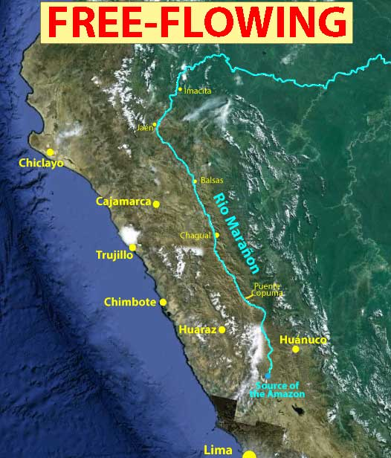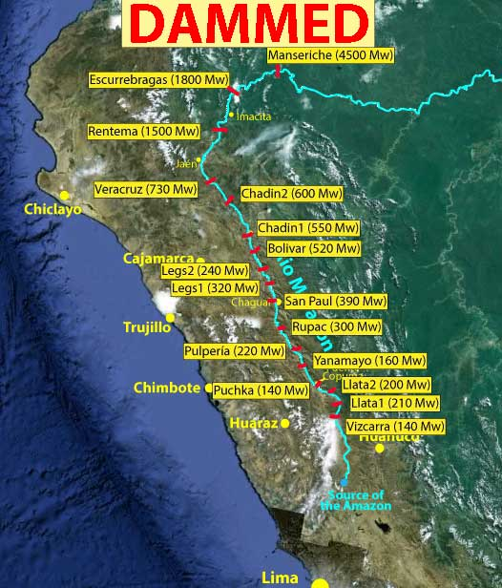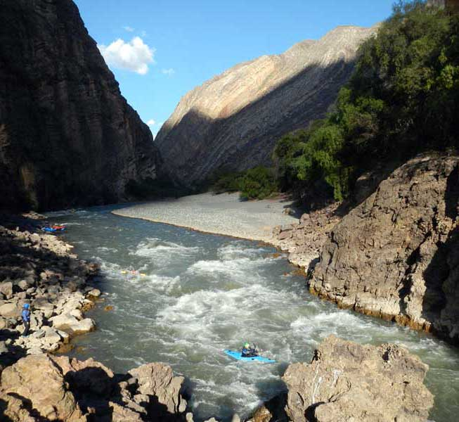

**MESSAGE:**A series of 15+ hydroelectric dams are planned for the Upper Amazon that will destroy

some of the most precious places on earth, including a **Grand Canyon equivalent**. The issue needs

to be publicized and the qualities of the river understood to save this incredible natural treasure.

See [SAVE THE UPPER AMAZON](http://www.sierrarios.org/Peru/SaveRioMaranon.html) webpage for more details and a [PETITION](http://www.thepetitionsite.com/857/771/803/stop-20-dams-planned-for-ro-maraon-the-upper-amazon/).

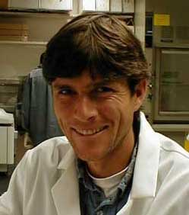 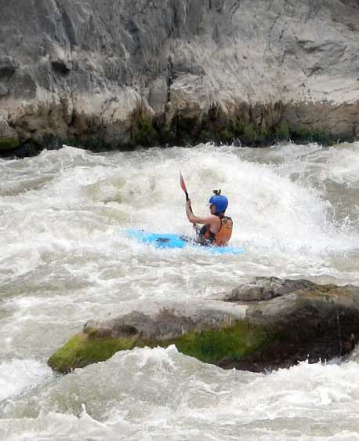 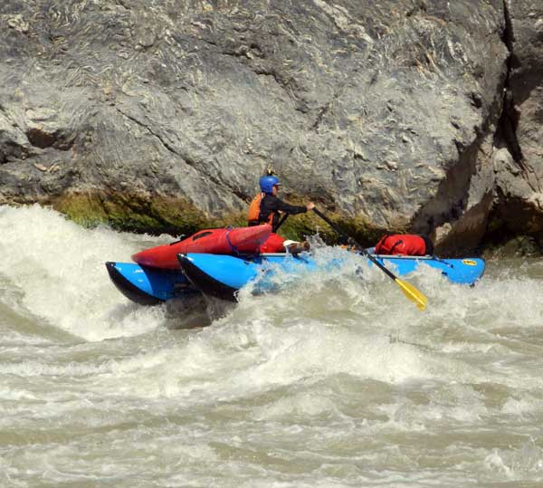 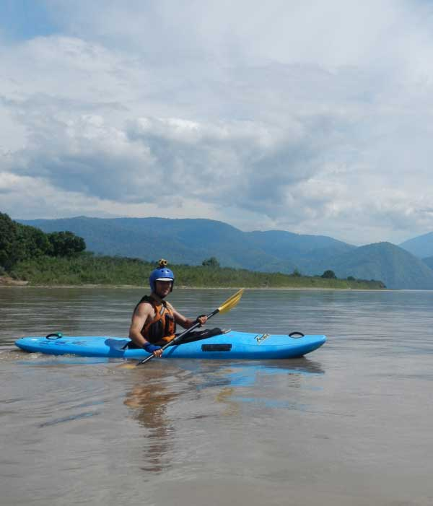

**EXPEDITION LEADER: ROCKY CONTOS**

Rocky is a well known and respected whitewater kayaker, sea kayaker, rafter, guide, conservationist,

explorer, author and scientist. He has completed >100 first descents and authored a guidebook + >40

outdoor and scientific articles. Biographical articles have appeared in American Whitewater (2007),

Kayak Session (2009), and Canoe & Kayak (2011). Rocky discovered the source of the Amazon,

authored the scientific article pinpointing it, and will publish a book on the topic. In 2012 he spent 6

months paddling all headwaters of the Amazon, then finished the descent to the ocean by motorboat.

***No source-to-sea paddle expedition has ever started at the true Amazon source.***

**MEDIA ATTENTION ALREADY**

- **Outside** article in January 2013 [LINK](http://www.outsideonline.com/outdoor-adventure/water-activities/Fastest-to-the-Atlantic-Wins.html)

- **Canoe & Kayak** article June 2013 [LINK](https://www.dropbox.com/sh/l1zk9c9aw7c9v98/GsMDBs8F3J)

- **Canoe & Kayak** Expedition of the Year Nomination

- **American Whitewater**: Jul-Aug 2013 [LINK](https://www.dropbox.com/sh/l1zk9c9aw7c9v98/GsMDBs8F3J)

- **International Rivers** article: Mar 2013 [LINK](http://www.internationalrivers.org/resources/rocky-contos-the-r%C3%ADo-mara%C3%B1on-7852)

**PLANNED MEDIA OUTLETS**

* webpage, blog, Twitter updates
* book, film
* articles
* news stories
* *sponsors to be promoted in media*

**GARNERING VIEWERS**

- the scientific article placing the correct Amazon source will be headline news

- to be covered by major news outlets (***Nat. Geo.,*** ***NY Times***, ***BBC***, ***NPR***, ***C&K***, ***Outside***, etc.)

* in all interviews, Rocky will direct attention to the upcoming expedition and planned dams

**SUPPORT REQUESTED:**

**- FINANCIAL**: $25,000: ***main contributor to be noted in expedition name***

**- BOATS:** Whitewater kayaks (3), Raft+frame (1), Sea kayaks (3), Paddles (4 ww/4 sea)

**- Camping gear** (tent/sleeping bag/ground pads/stove/headlamp/water filters/etc.)

**- Communication units** (satellite phone, GPS units, SPOT tracker)

**- Food** (prepackaged dinners, energy bars)

- **Apparel** (drysuits, fleece, wool shirts/pants/socks, footwear, jackets, spray skirts, helmets)

- **Climbing gear** (rope, anchors/etc, crampons, helmets)

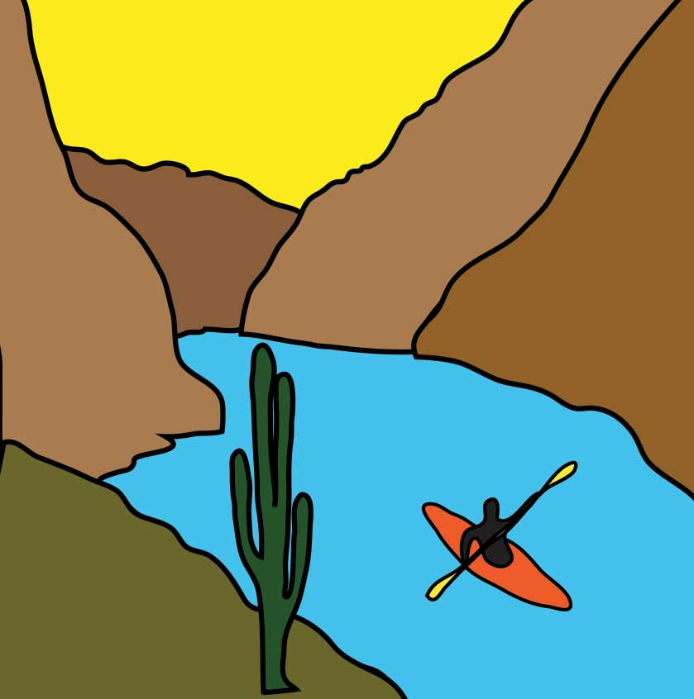CONTACT: **Rocky Contos** ***SierraRíos***

rocky@sierrarios.org *A 501(c)3 non-profit conservation organization*

206-484-5820 **James “Rocky” Contos, PhD**

[www.SierraRios.org](http://www.SierraRios.org) **Founder and Executive Director**